**The Spirit Code**

**Christ-Centered Energy Healing**

**­­­-----**

**Compounds and Charts**

Written by Paul and Melissa Bunch

ISBN-13:

978-1540816139

ISBN-10:

1540816133

Table of Contents

Section One: Purpose of Forming a Compound . . . . . 1

Section Two: How to Form a Compound . . . . . 3

Section Three: Template . . . . . 9

Section Four: Examples . . . . . 13

Section Five: Charts Used For Compounds . . . . . 16

Section Six: Five Elements . . . . . 32

Section Seven: Additional Charts . . . . . 34

Section One:

Purpose of Forming a Compound

Energy grouped to together for a single purpose is what we call “energy compounds” or “compounds of energy” or simply a “compound.” There are many reasons ways in which a compound can increase the healing capacity of an individual. For instance, compounds of energy can:

1. Assist in removing pathogens
2. Assist in removing toxin and poisons (identified differently within a body)
3. Break down physical blocks within the body
4. Assist in breaking down excess (such as “excess dense tissue,” which can be created by a person’s body to store negative energy)
5. Assist in healing damage to the body

Let’s take for instance a human form is devised of cells and particles from the universe. Imagine this universe is alive and ever moving, ever changing and ever evolving. The body would follow suit to this powerful universe. A body created at the time of Adam and Eve or even Moses does not have the same chemical make-up as a body created in the modern universe. Why is that? Have you ever studied how mankind lived hundreds of years in generations past and wondered how this could be possible? Assuming it was not a misprint or miscalculation of the seasons, this could not be possible even with modern medicine. Yet, it was so and even common as life was vastly different in the pre-modern society of the era before the great flood. Evolution has occurred but in a different manner than we have perceived by our limited understanding upon this planet. We see a certain outcome and misunderstand the entire complexity of the picture created by an all-powerful God.

**Energy is all around. Everything is alive in its own respect. Intelligence of the universe runs deeply throughout every particle of existence. Once you choose to connect to this intelligence and offer it respect - respect for the Creator and respect for its existence, then this energy may choose to serve you in alignment with the will of the Lord.**

These compounds of energy are quite simply ingenious; working together with the universe and the energy within to increase the capabilities of the human body to grow, heal, mature and evolve. We simply remove all we think we know about the chemical makeup and begin asking the energy itself in alignment with the body how to increase the speed of healing. We ask, what does my body need and then simply invite the energy of this intelligence into the human body through the meridians and to then be distributed throughout the body to the desired location. All through muscle testing. The sky is the limit; however abuse of these energies will decrease the unity of the progress. Having faith in God’s creations and respect for them while working in conjuncture with these energies, will offer your body the ability to produce healing at a growth unknown to the medical world.

Simply put, the world has so much more potential that we are not utilizing as we designate our own will above the ability of God. Compounds are a beginning to the lessons we are ready to learn about the potential of the earth to heal our bodies. Of course, not to be forgotten; the healing in the mind and spirit, this is just one piece of the puzzle.

This is not a selling tool as we do not sell these products. We are communing with them and inviting their energy into our bodies. In the case your body is not capable of digesting or absorbing certain minerals, vitamins or nutrients; this invitation of energy is more effective than simply ingesting. When we invite in this energy it is without additives or GMO, because we are inviting into our bodies the creations of God. This is a small step towards becoming one with the universe and all of creation as we act as one in body, mind and spirit.

Negative energy is toxic to the body. Your body is a temple for your spirit. Your body and spirit are holy and sacred. Any memory, emotion, event, experience that creates negative energy is going to cause harm to your sacred body. Becoming aware of faulty patterns, changing the outlook on the past and expectations of the future will create a safe space for healing. Our goal is to spiritually and physically prepare for the second coming of Jesus Christ. Many see preparations as simply food and water storage, however having a body of health and strength along with spiritual awareness is one of the most basic preparation steps. The higher law entails being worthy in thought. Until we can heal from the wounds of the past and change our outlook on reality, the ability to have Christ-like thoughts will be near impossible as we naturally respond emotionally. This is further explained in the Spirit Code Self-Sabotage manual. Moving forward differently than you have in the past to experience different results requires a conscious effort which also requires shifting the core beliefs. If a tree in your orchard is producing rotten fruit; the root system must be healed before the fruit produced is healthy. The positive energy included in the compounds will counteract the impact of the negative energy on the body for as long as it is invited in properly, thus creating a balanced body where healing can occur.

The complete Spirit Code program is available online as it is complicated and requires visual lessons. Please visit spiritcode.net for complete classes on how to properly assist the body in healing in the spirit, mind, and body.

Section Two:

How to Form a Compound

We begin by using a template with 14 different types of energy that can be combined or merged within their own category. The sky is the limit and more categories may be created as the Spirit prompts. Each category has a chart and through muscle testing you can fill in the blanks with the needs of the individual. If an item is not listed, begin searching the internet for the specific needs or allow intuitive inspiration to guide the results.

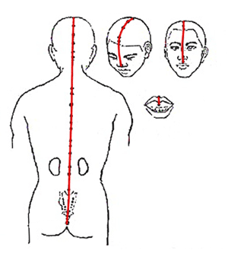We recognize that these energies are gifts from God and should be treated as such. When working with the energies we **invite** the energy into our bodies through the governing meridian and to be distributed to the desired locations. Energies have their own form of intelligence, which is how they respond to a person’s invitation. We do not want to restrict their free will, since that has the potential of turning them into negative energy. So when we are working the energies, we are communicating with them and asking them to assist us. There are 12 “regular meridians” or “main meridians” within a person’s body and eight extraordinary meridians. The extraordinary meridians act as energy reservoirs. The governing meridian is an extraordinary meridian the flows up a person’s back and over the top of a person’s head.

The governing meridian can flow into other meridians, allowing the energy to be absorbed into any part of the body. When working with the skin, sometimes it is best to invite the energy into the person’s energy fields and have it bathe this skin or absorbed into the skin. Other locations exist, to include: inviting the energy directly into a chakra, or directly into a pathogen, such as a parasite. Forming compounds outside of a person’s space can be done to remove toxins and pathogens (fungus, mold, bacteria, and virus) within a person’s home, vehicle and workspace. For obvious reasons, it is important to remember to remove the bacteria and viruses from these locations after removing them from a person’s body.

While working with the energies, we follow Dr. Bradley Nelson’s technique of using a magnet. The magnet will intensify/magnify the mind’s intention and the flow of energy within the meridian. The magnet, which can be a simple refrigerator magnet, is run over the governing meridian, either over the top of a person’s head (from front to back) or down a person’s back. In the case where blocks are present in the meridian, this must be removed before continuing.

We begin by bringing to light the imbalance (imbalance – referring to the health problem, whether it a negative energy, a pathogen, toxin, etc.). For example, if the purpose of inviting in the compound is to remove parasites within a person named Marvin, this can be done by simply stating, “I bring to light all parasites within Marvin.” (As a reminder, when removing parasites, also remove the eggs and the dead parasites that remain within a person’s body.)

We group the 14 energy categories into “Group A” and “Group B.” Each group will have a different set amount of time. We use muscle testing to designate the appropriate time frame for each group based upon the client’s needs.

1. Group A: will typically be invited to work continuously for a certain length of time. Group A is for the healing the damage caused to body. This group contains oils, herbs, nutritional supplements, spiritual energy, and much more.
2. Group B: is more intense than Group A and will typically be invited to work in intervals. Group B typically breaks down an imbalance within the body, such as the toxins, pathogens, excess, etc. Group B has the potential to harm the body if it remains longer than necessary. It is typically broken down into minutes or hours: For instance, Group B could be invited into a person for 3 hours, 3 times a day for 5 weeks and 10 days. With intervals, Group B can work in harmony with Group A, since Group A can continue to heal while Group B takes a break. Keep in mind that the total number of days Group A and Group B will be the same. So if Group A is invited into a client’s meridian for 10 days, Group B will also be invited in for 10 days.

Since Group B has the potential to harm the body if it remains beyond the necessary time, it is important to make sure the energy is released at a specific time. To do this, a person can set the intention for Group B to be neutralized, defused, released and removed. It can be stated as follows, “I set the intention for Group B to be neutralized, defused, released and removed after the space of time specified for each treatment.”

It is common to have multiple energies within a category. Before identifying the energies, a practitioner can muscle test to see how many energies will be needed within the category. For instance, if a practitioner is adding emotional energies to a compound that requires four emotional energies, the practitioner can muscle test while stating, “Does this compound need one energy, two, three, four, five?” On number five, the test will be weak. This will indicated that the needed number is four, since it was still strong.

For each of the categories there is a chart to assist in identifying the specific energy. To identify the energy the practitioner must use muscle testing. The practitioner tests which column and which row the energy is in. For instance, when identifying an oil, a practitioner can first test to see if the oil is in Column A, B, C or D. This can be state as, “Is the oil that Marvin’s body needs in Column A?” If the test is positive, then test for the appropriate row the oil is located in. If negative, then proceed to the following columns until the test is positive. The practitioner will do the same with the rows. For the oils, there are five rows. If desired, a person can also test to see if the oil is in odd or even rows to narrow it down a little quicker. This can be stated as, “Is the oil in an odd row?” If it is a negative, then test for even rows. As a practitioner becomes more adept at testing, the practitioner can use their intention to assist. They can simple state the column, row, etc., rather than going through the full question.

Once the column and row has been identified, the practitioner can test each oil within that block. For example, if the oil is in Column C and Row 2, the practitioner will then have the following six oils to test: black pepper, cajuput, rosehip, baobab, marula and neem. (see chart on following page) After becoming comfortable with the process, the practitioner can simply think of the words to properly test. If the test is positive, that is the oil that is needed. If the test is negative, continue testing until a positive result is received.



While testing each energy within a block, two unexpected possibilities may arise. 1) Occasionally, a negative result for each energy within the block will occur. This means that the energy that is needed is not listed on the chart. 2) Depending upon the method of muscle testing, it is possible to receive an answer that is not real strong or real weak. This can be identified by practitioners that are very confident and proficient with their muscle testing. This is an indication that the energy needed is close to the energy listed. For instance, when testing the herb “lily of the valley root” the test was between weak and strong. The particular energy needed was from the pollen, instead the root. In other instances the energy may not be part of the same plant, but instead a closely related plant. For example, there are many types of berries and the “close” result may land on a huckleberry, but the needed energy is a lingonberry, a cousin of the huckleberry. When a test result is negative or close, do not get discouraged. Relax and allow some inspiration to come into your mind. If, in the end, you are unable to identify the correct energy, acknowledge that there is an energy that is not listed and invite the energy to assist.

Depending upon the category, the practitioner may combine or merge the energies after inviting them to work with the client. The template provided in Section Three indicates whether or not the category can be combined or merged. Additionally, the lines 4 through 11 within Group A will often times need to be concentrated based upon each person’s needs. The combining and concentrating can be done in conjunction with each other. For instance, when inviting herbs into a client’s meridian, the practitioner may state, “I invite and absorb into Marvin’s meridian the herbs echinacea and white willow bark and I invite each of the herbs to concentrate based upon his needs and I invite them to combine.”

The elements are the first category in Group B. The elements are the only category that we merge. When two elements are merged they become a molecule. The merging of elements into molecules can become very complex; however, while working within a compound the need for a complex molecule is typically unnecessary. Within a compound it is common to have only one molecule that is comprised of two or three elements. The elements we work with are not limited to the ones identified by humans on a periodic chart, which stop at #118 (the atomic number – see image on the following page). The elements offered by the earth can reach into the tens of thousands. We can also invite elements from other planets, moons and stars to work with us. It is important to understand that the energy of these elements is being invited to assist in healing or breaking down of blocks or dense tissue. The energy of these elements has different properties than that of their physical counterpart; however, their intelligence and capabilities far surpasses our expectations.

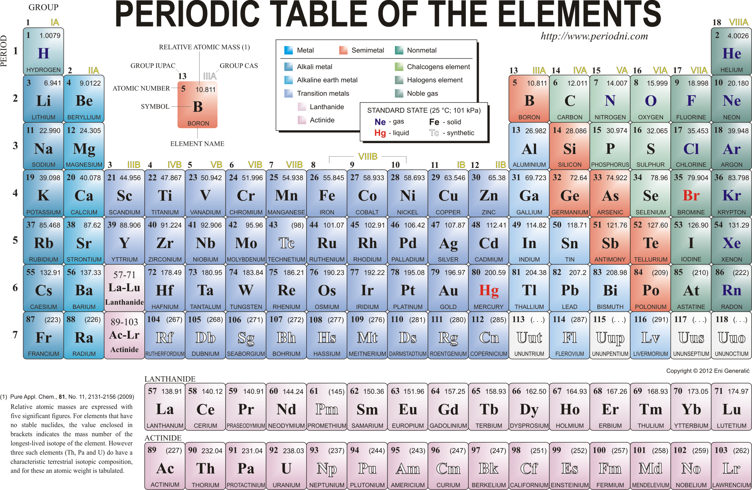

The following steps assist with the identification process:

* 1. Test to see how many molecules are needed for the compound
  2. Test how many elements are needed within each molecule
  3. Test which elements (test the atomic numbers 1 – #####?) are needed (elements are not limited to the 118 identified by humans)
     1. This can be done by testing to see if the number is 50 or below. If positive, then cut the number in half and test if it is 25 or below. Continue this process until the number is identified. A similar method can be used for numbers above 50. To narrow down the number, the practitioner can test to see if the number is above 50, 100, 200, 1,000, 10,000, etc. until a negative result is reached. Then the begin cutting the range in half.
  4. Test to see if any **sun elements** or elements from any other location are needed (sun elements begin at 136)
  5. **Order of merging**: Examples:
     1. Ex.1: You may have four elements that need to be merged into a molecule; however, three of them may need to be merged first and the fourth element added to the molecule formed by the first three.
     2. Ex. 2: You may need to form three molecules and merge all three to form a new molecule. Again, test to see if all three molecules can merge at the same time or if there is a specific order that needs to be followed.

Energy waves may seem intimidating at first, but after a few times practicing it is actually a pretty simple process. There are two kinds of energy waves that we work with, light energy waves (sometimes called electromagnetic waves) and sound waves. Compounds typically used only one light wave; however, occasionally two light waves will be needed. Of note, light waves travel vertically and sound waves travel horizontally.

Charts are provided to identify the type light and sound waves. Frequencies and vibrations are the measurements of energy. We use abbreviations to simplify the charts: F = frequencies and V = vibrations. This is a common practice throughout all of our work. When identifying the proper F and V needed, a practitioner needs include whether it is a positive or negative F and V. Almost always the F and V will both be either positive or both be negative. On the very rare occasion a practitioner may come across an energy wave that requires the F to be positive and the V to be negative or vice-a-versa.

The F and V will each be identified with a number. The number will always have a decimal point in it. For example, the frequency may be 26.7 and the vibration 17.9. A practitioner may test to see how many digits are before the decimal and how many are after the decimal. In order to identify the number, the testing can be done in a similar manner as described above for the elements on a periodic chart.

The last category of energy is the chemicals/hormones. The chemicals are tailored to each individual’s needs. For instance, while using a compound for the same purpose on two different clients, one client may need the chemicals of adrenaline and cortisol and the other client may need chemicals of insulin and glucagon. The chemicals are broken down by the gland that excretes the chemical. A practitioner can identify the gland first and then test each chemical to identify the ones needed.

After each energy has been identified within each category, the practitioner can begin inviting the energy into the most appropriate location. When doing this, remember that the intention is the most important part. With that said, there is no set way to do this. An example of how this can be done is as follows:

I invite and absorb into my meridian group A (list off all the components in group A) to be continuously invited into my body for (amount of time) and to be distributed throughout my body for the purpose of reducing inflammation. I invite and absorb into my meridian Group B (list off all the components in Group B) to be invited into my body for (amount of time) and to be distributed throughout my body for the purpose of breaking down the toxicity creating inflammation. I neutralize and defuse, release and remove Group B after the space of time specified. I lovingly thank these energies for their service and assistance. Where necessary, combine or merge and/or concentrate the energies based upon the needs of the body. Also, **synergistically combine all of the energies together.** Synergistically combining the energies will multiply their effectiveness.

**Conclusion**

When broken down into each category, we are able to more specifically calculate the needs of the human body. Energy is raised with higher frequencies and vibrations; however these levels raise based upon our own capability, faith, health, spirituality, knowledge, positive flow of emotions and evolution. When a level is low, it can be raised. We can raise the F and V of our water to increase the hydration for our bodies simply by playing hymns to a jug of filtered water. The same can be done with our food sources by offering it respect, positive energy and joyful sounds in the home. Respect for the energies that sustain life, increases the F and V of their energy flow. When there is contention in the home, the F and V of the food in the pantry can actually receive negative energy flow, thus decreasing the health of the body that consumes that food. It is said that a blessing over the food will increase the F and V of the food we consume; however, it can also be increased even more due to the energy we release from our bodies. If you stop and think about the process of the food that you are about to eat from the beginning of its existence until the moment it touches your mouth and then until it completes the digestion process within your body; a healthy respect is formed between you and the food. On the other hand, if you eat unconsciously and send hateful thoughts to the spare tire around your waist and complain about your body’s poor health, the ability of the body to rise to healthier standards is borderline impossible.

In the end, we are working off faith. We receive the results we expect. When an individual is not willing to heal or is unbelieving, this process doesn’t work. The spirit and the mind and the body must be working together as a team. When we desire to heal another who is not ready, this process will be rejected and healing will discontinue. The intelligence of this energy respects God’s plan of agency. Whenever we consciously or subconsciously reject the energy, it will discontinue its treatment. This is not to say we do not desire healing, but until we are fully ready to come unto Christ with a pure heart, we may still reject the process. We limit the capabilities of the human experience by placing our own limits upon our existence. We are all mortals and we are all here together to experience life. **Once we learn how to live in peace with one another and accept ourselves and God, we will begin to see a change in our results. Then we can see the remaining capabilities of our bodies and what lies ahead.** **These compounds are a small fraction of what we are capable of doing. Christ taught us that we can move a mountain if only we had the faith of a grain of mustard seed.**

When understanding curses and dark energies, lifestyle energies, sexual and destructive energies; compounds greatly assist, but you can go much further with the earth’s involvement. Most times we are not alone in this experience of life and, therefore, we are not alone in the healing process either. Taking steps alone is futile and will lead to emptiness as the healing journey must exist in a space of a support system. Always take with you a friend that will not let you down. For many, this is family or friends, while others find their refuge in the Lord. Might the earth be added to this list along with the many other creations of God. The sun has healing properties that are well known, but the earth stabilizes life by providing nourishment within her soils. Many overlook her involvement, but **her partnership offers the potential to live in ways that would not exist without her**. **Therefore, healing also involves the earth’s abilities to enter into the body’s cavities and fill you up with countless energy, vibrations, connection, purpose and healing**.

Section Three:

Compound Template

Group A:

1. Spiritual energies: _______________________________ – **combine**
2. Emotional energies: _______________________________ – **combine**
3. Love and strength of Spirit Animals: ___________________– **invite**
4. Oils: ________________________________ – **combine**
5. Precious stones: _______________________________________ – **combine**
6. Nutritional Supplements: ______________________________________ – **invite**
7. Bacteria: ______________________________– **combine**
8. Herbs: _______________________________– **combine**
9. Foods: ________________________________ – **invite**
10. White powder gold + Chlorophyll + O17 + Mumio – **combine**
11. Ionized Water + Kombucha – **combine**
12. 8 hrs of restful sleep daily (NREM stage 3)

Group B:

(F = Frequency; V = Vibration)

1. Elements: __________________________________ – **merge**
2. Light energy wave: ____________________________

positive/negative F ______ & V______ – **combine**

1. Light energy wave: ____________________________

positive/negative F ______ & V______ – **combine**

1. Sound wave: ____________________________

positive/negative F ______ & V______ – **combine**

1. Chemicals/Hormones (based upon individual’s needs): ­­­­­________________________ – **invite**

Note – Remember, many of the energies on lines 4 through 11 may need to be concentrated

Note – Ask if anything else needs to be added

Invite the energy above to **synergistically combine**

Group A Time: ## days

Group B Time: ## hour(s) / ## times a day / ## days

For the times: Invite the group of energy into the meridian (or the appropriate location) for the space of ## and ask for the energy to combine and merge based upon its needs

Ask for the group of energy to be distributed to the proper locations within the spirit, mind and body

Set the intention for it to be Neutralized / Defused / Released / Removed after the space of time specified for each treatment

Lovingly thank these energies for their service and assistance

Step by Step

Bring to light all . . . (Ex.: bacterial infections)

Invite and absorb each grouping **into the meridian** to merge or combine

- Or into the appropriate location such as the energy fields (to bathe the skin), a chakra, directly into the affected area (such as a pathogen), or into a home, vehicle or workspace. These are not the only possibilities, so let the Holy Spirit guide you as you look for the correct location.

Group A

1. Spiritual Energy: These energies are Godly in nature
2. Emotional energy: extremely vital in the healing as most problems occurred originally from negative emotions – then combine the emotions
3. Love and Strength of Spirit Animals – this is a special opportunity to join together with the animals that watch over and protect you and allow them to assist in the healing process.

- Lines 4 through 9, simply test to see which energies are needed

1. Oils: test for which oils are needed – combine
2. Precious Stones: – combine
3. Nutritional Supplements: – invite (Due to the wide variety of possibilities, we do not combine these energies)
4. Bacteria: – combine
5. Herbs: – combine
6. Foods: – invite (Due to the wide variety of possibilities, we do not combine these energies)
7. White powder gold + Chlorophyll + O17 + Mumio
   1. Notes: the white powder gold (WPG) assists in binding the previous groups of energy together. WPG has a unique ability to be used in a physical form and a spiritual form. Nano-gold is a man-made version of WPG and can only be used in a physical form. Due to the spiritual nature of WPG, it is important to acknowledge this element as pure and holy. Chlorophyll is rich in nutrients. O17 is type of oxygen atom; although this element has not been extensively studied for its healing abilities, we have discovered that it has incredible power to heal. Mumio is also known as shilajit. It is a naturally occurring substance that is also rich in minerals, as it is grown on rocks. Multiple studies have shown a wide variety of health benefits from mumio, but the magic behind its healing properties has continued to elude the scientists.
8. Ionized Water + Kombucha – **combine** to assist in hydrating the body.
   1. Notes: Ionized water is formed into smaller water clusters than a normal water cluster, thus, allowing the body ionized to absorb it more efficiently. Kombucha, a drink, is packed with probiotics, enzymes and other nutrients.
9. 8 hrs of restful sleep daily (NREM stage 3) to assist in the healing process especially
   1. Notes: The effected part of the body often needs rest to heal. 8 hrs is the most common amount needed; however, there are some instances where a client may need either less or more hours. NREM (non-rapid eye movement) stage 3 is the stage in which a person goes into the deepest level of sleep.

Group B

1. Elements: test for which elements are needed – **merge** the elements to form molecules
   1. Test to see how many molecules are needed for the compound
   2. Test how many elements are needed within each molecule
   3. Test which elements (test the atomic numbers 1 – #####?) are needed (elements are not limited to the 118 identified by humans)
      1. This can be done by testing to see if the number is 50 or below. If positive, then cut the number in half and test if it is 25 or below. Continue this process until the number is identified. A similar method can be used for numbers above 50. To narrow down the number, the practitioner can test to see if the number is above 50, 100, 200, 1,000, 10,000, etc. until a negative result is reached. Then the begin cutting the range in half.
   4. Test to see if any **sun elements** or elements from any other location are needed (sun elements begin at 136)
   5. **Order of merging**: Examples:
      1. Ex.1: You may have four elements that need to be merged into a molecule; however, three of them may need to be merged first and the fourth element added to the molecule formed by the first three.
      2. Ex. 2: You may need to form three molecules and merge all three to form a new molecule. Again, test to see if all three molecules can merge at the same time or if there is a specific order that needs to be followed.
2. Energy Waves (First Light / Sound second) – Test to identify the type of energy wave needed and then invite that energy wave into the meridian. (Note: These waves have the ability to break down the blocks in the spirit).
   1. Test for the frequency
      1. Ask the number of digits before the decimal; Identify each digit
      2. Ask the number of digits after the decimal; Identify each digit
   2. Test for the vibration
      1. Ask the number of digits before the decimal; Identify each digit
      2. Ask the number of digits after the decimal; Identify each digit
   3. Test for positive or negative
   4. Invite each in and combine the frequency and the vibration
   5. Example: Ultraviolet wave Frequency of negative 26.7 and a Vibration of negative 17.9
3. Hormones:
4. Ask if there is anything that needs to be added to this group of energy
   1. Ask if this group of energy is whole / complete

Note – Remember, many of the energies on lines 4 through 11 may need to be concentrated

1. Invite the energy above to synergistically combine
2. Ask that your meridian distribute these energies to the proper locations within the body or to a specific location in which the energy is needed
3. Time it:
   1. Group A may take several days
   2. Group B will be in intervals – a certain amount of minutes or hours / a certain amount of times in a day (example: 4 times a day) / for a certain amount of days.
      1. Note: The total number of days in Group A will be the same amount of days in Group B.
4. Set the intention that this energy group be Neutralized / Defused / Released / Removed after the space of time specified for each treatment
   1. Note: On the rare occasion the energy will not need to be time or neutralized, etc., because it is likely converting something within the body; if so, nothing else needs to be done
5. Additional questions a practitioner may ask if they feel it is necessary:
   1. Is safe compound safe for (client)
   2. Will this compound overwhelm (client)
      1. If so, what percent (10%, 20%, etc.)
6. Thank the group of energy for its assistance

Section Four:

Examples

The first two examples are for removing physical blocks within a person’s body. A physical block may occur for many reasons including scar tissue which interferes with the flow of energy in the meridian. Other times the body can create a block of energetic flow as protection from a memory or event that created such distress it is harming to the individual. Until the flow of energy is cleared of all blocks (energetic and tangible), there will be limitations to successfully releasing negative energy or inviting in positive healing energy.

**Example 1:**

1. **Bring to light all blocks** in the spirit, mind and body
   1. Group A:
      1. Spiritual energy: Faith in God’s will + The pure love of Christ – **combine**
      2. Emotional energy: Fulfillment + Peace + Cherishment – **combine**
      3. Strength and love from Spirit animal’s: Dove + Komodo Dragon – **invite**
      4. Oils: Rosewood + Wintergreen + Sage – **combine**
      5. Stone: Coral + Sillimanite Cat’s Eye – **combine**
      6. Nutritional Supplements: Omega 3 + Isoleucine + Colloidal Silver + Hesperidin + Chromium – **invite**
      7. Bacteria: S. Faecium + SBO #2 + Bacillus Coagulans – **combine**
      8. Herbs: Hawthorne flower and berry + Burdock seed – **combine**
      9. Foods: Lychee + Kelp+ Kale +Barley + Mangosteen – **invite**
      10. White powder gold + Chlorophyll + O17 + Mumio – **combine**
      11. Ionized water + Kombucha – **combine**
      12. Energy of 8 hrs of restful sleep each night (NREM stage 3)
   2. Group B:
      1. Element: Hydrogen + Neon – **merge**
      2. Light wave: Cosmic wave – negative F 75.1 & V 81.1 – **combine**
      3. Light wave: Radio wave – positive F 6.6 & V 5.1 – **combine**
      4. Sound wave: Infrared – positive F 4.5 & V 2.3 – **combine**
   3. **Synergistically combine all of the above**
   4. Group A Time: ## Days
   5. Group B Time: ## hours / ## times a day / ## days
   6. Invite the group of energy into the meridian for the space of ## and ask for the energy to combine and merge based upon its needs
   7. Ask for the group of energy to be distributed to the blocks **that are safe to be removed** within the spirit, mind and body
   8. Set the intention for it to be Neutralized / Defused / Released / Removed after the space of time specified for each treatment
   9. Lovingly thank these blocks for providing protection in the past and thank the group of energy for providing their service and assistance

**Example 2:** This energy compound will breakdown the blocks on a person’s transmitters and receivers. The transmitter and receivers are a small, but important part within the nervous system. Because they are exceedingly small and delicate, it is necessary to form a special group of energy to remove the blocks.

Remove **blocks upon the transmitters and receivers**

1. Bring to light all blocks upon the transmitters and receivers
2. Identify whether all blocks are safe to remove
   1. Detach the blocks
   2. Detach the cords to the blocks / Cut the cords to the blocks with an Alternating Sapphire Current Laser / Release the cords / Remove the cords
   3. Invite and absorb into the meridian –
      1. Group A:
         1. Spiritual energies: Freedom with God’s Plan + He is my pattern and eternal friend – **combine**
         2. Emotional energies: Encouragement + Balance – **combine**
         3. Love and strength from Spirit Animals: Leech + Octopus + Eel + the energy of the idea/myth of the Loch Ness Monster + Cabbage worm – **Invite** (These animals are symbolic of something that is elusive and lurks beneath the surface).
         4. Oils: Eucalyptus + Neem – **combine**
         5. Stones: Diamond + Iolite + Star Moonstone – **combine**
         6. Nutritional Supplements: Iodine + Phosphatidylserine + DHA + Collagen Supplements – **combine**
         7. Herbs: Eucalyptus leaf + Partridge Berry + Gotu Kola + Kava + Tulsi – **combine**
         8. Foods: Pomegranate peel + Flaxseed + Poria + Flaxseed and Cottage Cheese + Mangosteen + Strawberry Cactus – **invite**
         9. White powder gold + Chlorophyll + O17 + Mumio – **combine**
         10. Ionized Water + Kombucha – **combine**
         11. 24hrs of restful, safe sleep daily (NREM stage 3)
      2. Group B:
         1. Compound / Molecule
            1. 1: Potassium + Lysine positive – merge and then add Lutetium to form the **PLL** compound
            2. 2: Holmium + Iron + Promethium + Erbium – merge and then add Lutetium to form the **HIPEL** molecule
            3. 3: Now merge the PLL compound and the HIPEL molecule to form the **PLLHIPEL** compound
         2. Light wave: X-ray: negative F 224.23 & V 235.25 – combine
      3. **Synergistically combine all of the above**
      4. Group A Time: ## Days
      5. Group B Time: # hours / # times a day / ## days
         1. Invite the group of energy into the meridian for the space of ## and ask for the energy to combine and merge based upon its needs
      6. Ask for this group of energy to be distributed to the all of the blocks **that are safe to be removed** and to break down the tissue forming the blocks on the transmitters and receivers
      7. Set the intention for it to be Neutralized / Defused / Released / Removed after the space of time specified for each treatment
      8. Lovingly thank these blocks for providing protection in the past and thank the group of energy for providing its service and assistance

**Example 3:** This example is provided to demonstrate the possible complexity of forming a compound with the elements. This was used to remove a staph infection. This was formed during the early learning process, so Groups A and B were not designated yet. When using just the elements, the result was a molecule. When adding something more complex, such as the antioxidants, we designated this as a compound. As you can see while studying it; this compound still needs a Group A with healing components. (Disclosure: Staph infection is a very serious bacterial infection. We, Paul and Melissa, would like to emphasize that we are not doctors and we do not diagnose. We recommend that you, the reader, follow your own judgment when seeking solutions to healing.)

**Staph Infections**

1. Compound for a Staph Infection
   1. Invite and absorb into the **meridian**
   2. Antioxidants + Iron = AI compound
   3. Protactinium + Tellurium + Lawrencium + Carbon = PTLC molecules
   4. AI + PTLC = AIPTLC compound
   5. Antioxidants + Iron = AI compound
   6. Nitrogen + Lutetium + Hydrogen + Dysprosium + Terbium + Gallium = NLHDTG molecules
   7. AI + NLHDTG = AINLHDTG compound
   8. AIPTLC + AINLHDTG = Staph Zapper + plus bind together with white powdered gold
   9. Then ask the meridian to distribute the compound to the **thymus gland** to be distributed to the blood stream by means of the heart
   10. Time it for ## minutes
   11. Neutralize and Defuse, release and remove

Section Five:

Charts











Additional: q-carbon



* Supplemental Product from Standard Process



Notes: There are other probiotics, SBOs (soil based organisms) and MBOs (marine based organisms) that are not listed and are unknown. When these are needed, a practitioner can test to see if the organism has a higher number than what is listed for the SBOs and MBOs. The practitioner can also simply acknowledge that is name is not recognized at this time and still invite the organism to work with the client while thinking of the unnamed organism. This can apply to all categories within the compound.





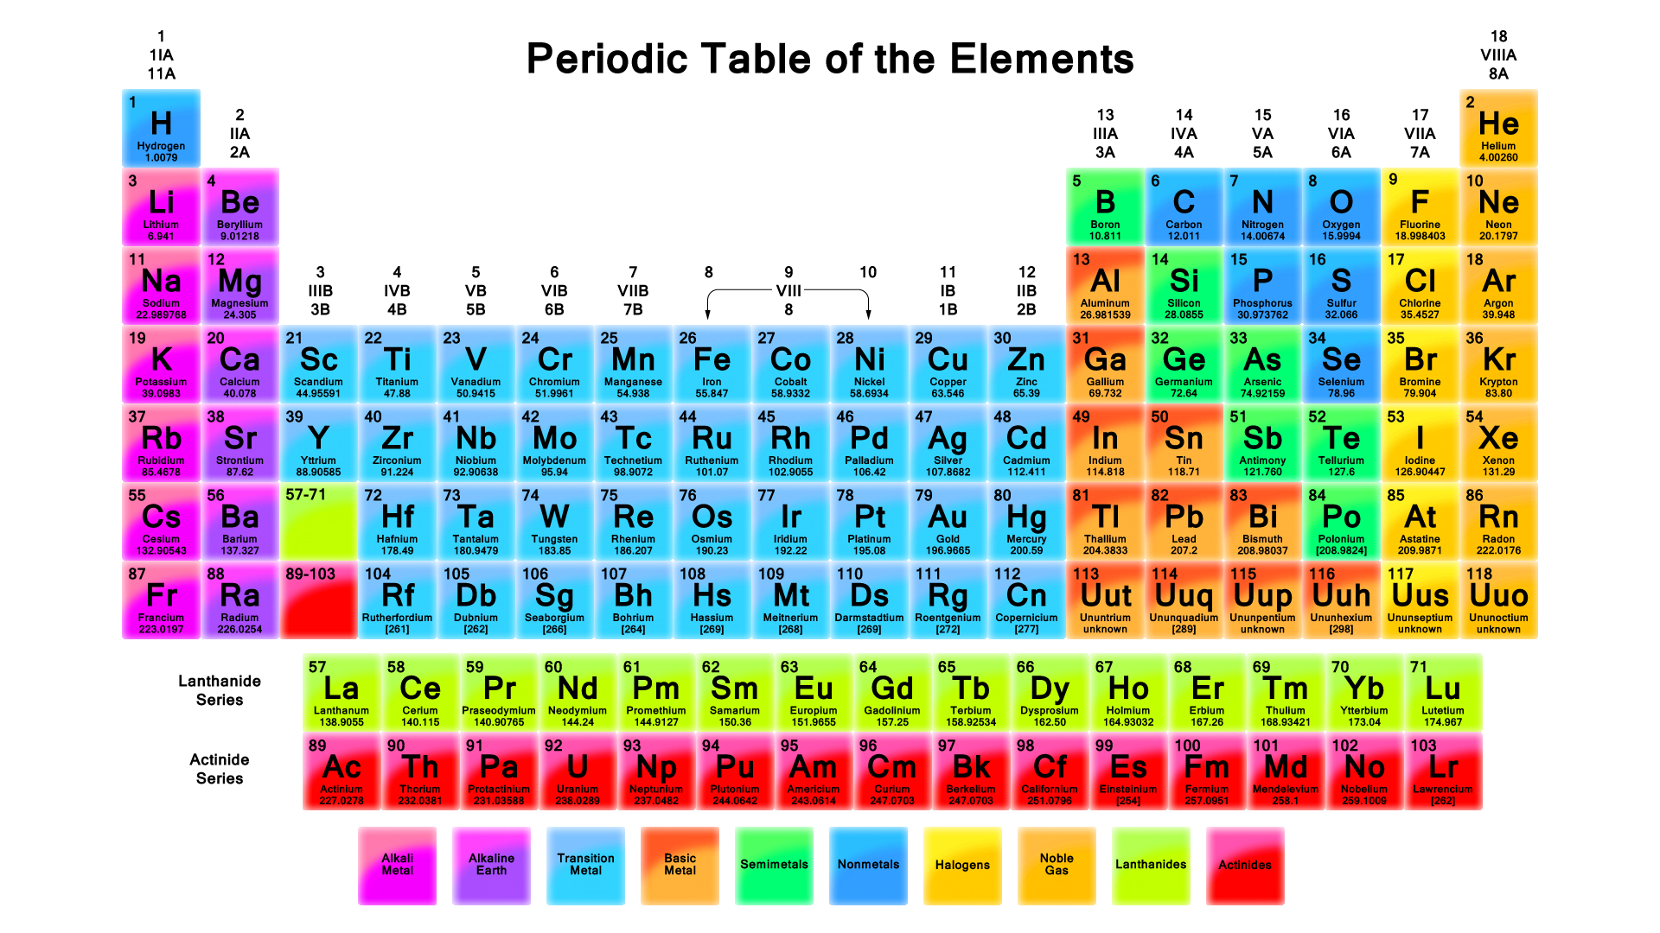



**Note: waves from the sun/stars and moon: use only a small fraction or portion**

Visual chart for light energy waves:

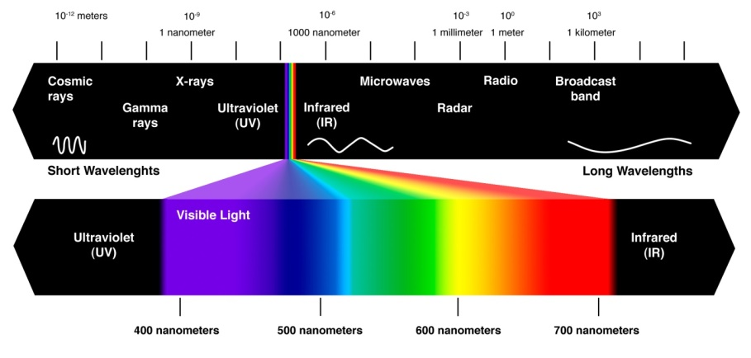



Visual chart for sound energy waves:

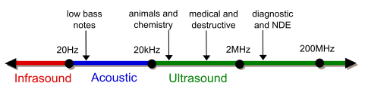





Section Six:

Five Elements

For those who become familiar with the practice of using energy compounds, there are two additional actions that can be taken. There are five elements (not the type that are on the periodic table) that can assist in the healing process. The information regarding the five elements is intentionally left vague. These are very powerful combinations and we encourage practitioners to seek heavenly guidance when using these energies.

First, the five elements can be invited into the body to assist into a person for healing for a universal healing of the soul.

Five elements in their proper order:

1. Love
2. Best earth element – 7 chakra elements
3. Best fire element – sun
4. Best water element – Ionized water
5. Best wind element – atmosphere (oxidation molecule is the best clean air molecule) Hydrogen + Nitrogen + Oxygen + Oxygen = **Merge** and then add Helium = H N O2 He

**Synergistically combine the above elements**

Test to see where these elements need to be invited in, such as the meridian / heart chakra / hypothalamus gland / skin.

Second, proper functioning allows the body to heal on its own, a practitioner’s assistance speeds this process by removing the components blocking healing from occurring. **Extreme cases require manipulation of periodic elements and some elements must be contained for maximum benefits**. **Containing requires blocking the morphing process with the basic four elements**.

**Properties are inherently transformational**. Relinquish the energy’s ability to transform itself - for the purpose of solidifying the element when emulsion occurs. **Relinquish by commanding the element** (periodic) **to backtrack its natural reaction** and control the reaction with the natural element of wind, fire, water or earth.

Two groups of energy will be needed. The first group will be comprised of energies in Group A and the elements on the periodic table. The second group will be the five elements.

Emulsify or combine the elements (periodic) and other energies, depending upon the situation. The following phrases can be used to backtrack the first group.

* “I backtrack this group of energy’s ability to naturally transform with love, earth, wind, fire and water”

Or

* “With the use of the elements of love, earth, wind, fire and water, I backtrack the first group of energy’s ability to naturally transform.”

Section Seven:

Additional Charts

Chakras and Energy Fields:

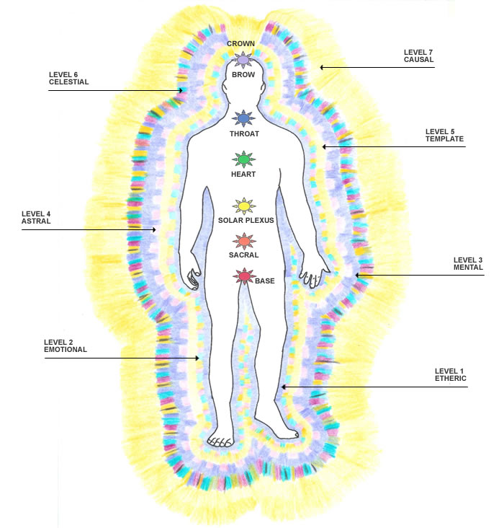

Glands and Organs:

